1. What is OOP?

object oriented programing is type of programing that is based on objects rather than just functions and procedures

1. Why use OOP?

* OOPs allows clarity in programing thereby solving complex problems in easy way.
* Code can be reused through inheritance thereby reducing redundancy
* Data and code are bound together by encapsulation.
* OOPs allows data hiding, therefore, private data is kept confidential.
* The concept of polymorphism gives flexibility to the program by allowing the entities to have multiple forms.

1. What are main features of OOPs?

* Inheritance
* Encapsulation /ɪnˌkæp.sjəˈleɪ.ʃən/
* Polymorphism /ˌpɑː.liˈmɔːr.fɪ.zəm/
* Data abstraction

## ****Classes and Objects OOPs Interview Questions and Answers****

1. What is an object? Object is instance of class. It has its own state, behavior. To create an object we use new keyword.
2. What is a class ? a class is template of object. A class contains properties and method.
3. What is the difference between a class and an object?

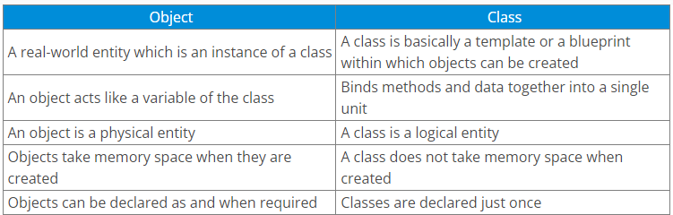

## ****OOPs Interview Questions – Inheritance****

10. What is inheritance? Allowing class inherit /ɪnˈher.ɪt/ properties from super class.

if there is a class such as ‘vehicle’, other classes like ‘car’, ‘bike’, etc can inherit common properties from the vehicle class

12. What is multilevel inheritance?

A class inherits from another class which itself is a subclass of some other base class.

## ****OOPs Interview Questions – Polymorphism****

**18. What is polymorphism?**

Polymorphism means (refers to the ability to exist in) multiple forms. For example, if you have a class named Vehicle, it can have a method named speed but you cannot define it because different vehicles have different speed.  This method will be defined in the subclasses with different definitions for different vehicles.

**21. What is method overloading?**

Method overloading is a feature of OOPs which makes it possible to give the same name which differ from each other by the type of input and output of the function.

**22. What is method overriding?**

 the subclass can redefine methods present in the parent class.

## ****OOPs Interview Questions – Encapsulation****

**25. What is encapsulation? https://www.sumologic.com/glossary/encapsulation/**

all the necessary data and methods are bind together and all the unnecessary details are hidden to the normal user.

#### In object-oriented computer programming (OOP) languages, the notion of encapsulation (or OOP Encapsulation) refers to the bundling of data, along with the methods that operate on that data, into a single unit. Many programming languages use **encapsulation**frequently in the form of **classes**. A **class**is a program-code-template that allows developers to create an object that has both variables (data) and behaviors (functions or methods). A class is an example of encapsulation in computer science in that it consists of data and methods that have been bundled into a single unit.

Encapsulation may also refer to a mechanism of restricting the direct access to some components of an object, such that users cannot access state values for all of the variables of a particular object. Encapsulation can be used to hide both data members and data functions or methods associated with an instantiated class or object.

#### **26. What are ‘access specifiers’?**

public, private and protected, default

#### **27. Java Access Modifiers**

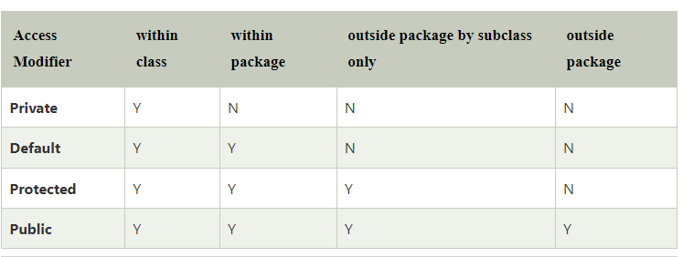

## ****Data abstraction****

## ****28. What is data abstraction?****

Data Abstraction is one of the most important concepts of OOP that shows only essential details to the user and hides the desired details from the users. All in all the main purpose of abstraction is to provide security.

## ****OOPs Interview Questions – Exception Handling****

### ****45. What is an exception?****

An exception is a kind of notification that interrupts the normal execution of a program.

### ****46. What is exception handling?****

An exception handler allows errors to be thrown and caught and implements a centralized mechanism to resolve them.